For my ignite project I used an NBA statistic PER to graph who is the greatest NBA player of all time. I also used the statistic to find who is the best current NBA player according to the stat.

What is PER (Player Efficiency Rating)?
The player efficiency rating (PER) is John Hollinger’s all-in-one basketball rating, which attempts to boil down all of a player's contributions into one number. Using a detailed formula, Hollinger developed a system that rates every player's statistical performance, and averages into a percentage.
PER attempts to calculate a player's per-minute output while accounting for pace. A league-average PER is always 15.00, allowing for season-to-season comparisons of player performance.
PER considers both positive and negative outcomes, including field goals, free throws, 3-pointers, assists, rebounds, blocks, and thefts, as well as missed shots, turnovers, and personal fouls. Using a statistical point value system, the formula adds positive statistics and subtracts negative ones. The rating for each player is then modified to a per-minute level, allowing substitutes to be compared to starters in discussions over playing time, for example. It's also tailored to the team's speed. Although PER is not a perfect statistic it is the closest thing to proving who is the greatest of all times as it factors in literally everything someone does in a game.

What did I do?
I gathered the top 100 players of all time and found there PER and then used excel to form a graph of there PER, I then found the top 100 players of the current NBA season and designed a graph to show who is the best currently according to the stat.

My Findings –
ALL time graph of Top 100 players PER
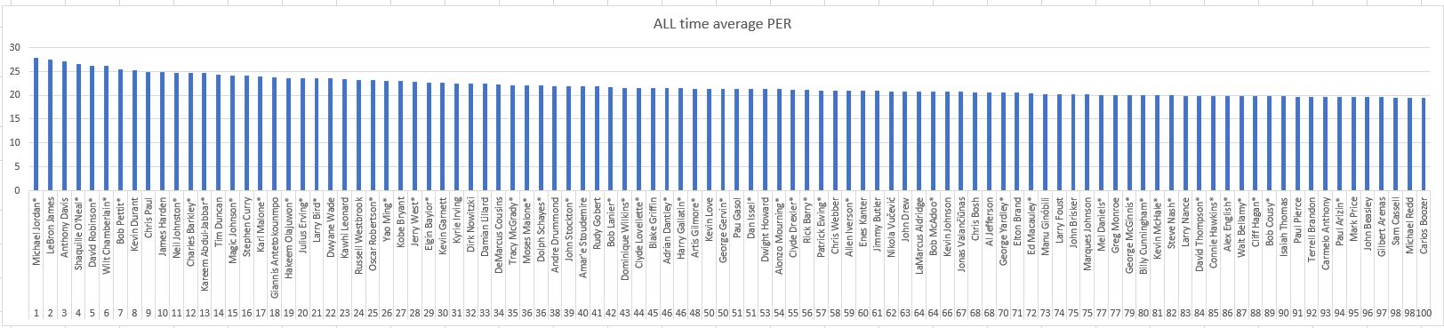
As the Graph shows Michael Jordan is only slightly statistically better then Lebron James, proving that he is the greatest NBA player according to this statistic.

Top 100 NBA players season 2021 PER –
2021 PER Graph

